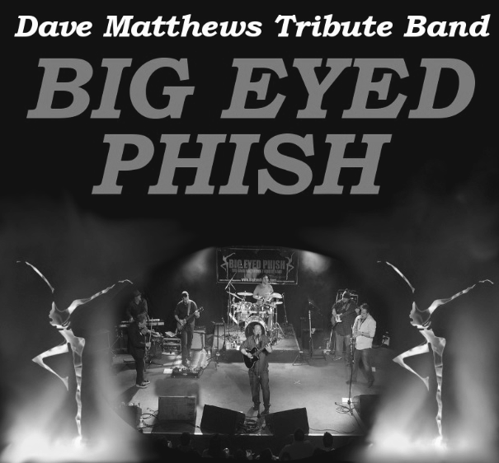
Rider package for the showtype:
Standard – Flight
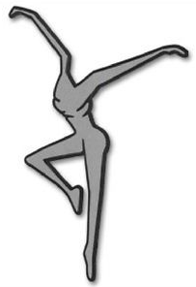
PLEASE ADVANCE SHOW WITH:
BRIAN DUDIAK
MANAGER / KEYBOARDS, BIG EYED PHISH – DAVE MATTHEWS TRIBUTE BAND
E: BDUDIAK@JUNO.COM
P: 1-585-802-9062 (CELL)
Thank you for choosing Big Eyed Phish - The Premier Dave Matthews Tribute Band
Considered by fans as “the closest thing you will see to a real DMB concert”, Big Eyed Phish prides themselves on their ability to put on a true live show. You will not find CD versions of songs, as it is the live shows by the Dave Matthews Band that has captivated a huge following of fans.

In order to provide the best quality of show, we recommend people review the following document in detail. Our product is a live show experience, which includes a combination of sights, sounds, musicians, and atmosphere.
For any suggested changes or substitutes to anything on this rider, please contact us directly. We look to accommodate the wishes and individual needs/requirements of each unique event and venue, so please feel free to reach out with any questions or concerns.
Our promise is to provide the most realistic live Dave Matthews Band concert experience that money can buy without having to contacting Dave Matthews himself!

_____________________________________
Brian Dudiak
Manager, Big Eyed Phish – Dave Matthews Tribute Band

Hospitality Rider
Travel/flights
- 7 airline tickets from a reputable carrier, economy class or better;
- Airport pick-up to accommodate 7 people, 7 instrument cases and 7 pieces of luggage;
- Transport from hotel to venue and vice versa in one or more vehicles to accommodate 7 people, plus 7 instrument cases.
Accommodation
- 4 rooms, 3 stars or better – breakfast included;
- 3 of 4 rooms to include 2 sleeping accommodations (double bed or larger)
- 1 of 4 room to include one sleeping accommodation (King preferred)
- Each room to have (free) WiFi internet service;
- Accommodation to be safe and all rooms secured by key or card.
Rooming List/Flights d.o.b.
- Brian Dudiak - January 31, 1982 - Room #1
- Dan Merkey – April 13, 1984 - Room #2
- Jonathan Sheffer – September 7, 1982 – Room #2
- Brandon Depaul – June 23, 1972 – Room #3
- Mike Hoeschele – April 22, 1950 – Room #3
- Shawn Rotolo – May 26, 1987 – Room #4
- James Grillo – July 21, 1987 – Room #4
Venue
- Minimum of two reasonably sized dressing rooms to include at least 1 bathroom facility;
- Dressing room to contain at least 1 mirror;
- Dressing room to contain seating area to accommodate at least 8 people;
- Limitless supply of bottled- or filtered water on stage and in dressing room;
- Dressing rooms to contain at least 1 coat rack for stage outfits;
- Dressing rooms to be tidy, clean and sufficiently illuminated;
- No public or unauthorized access in any area designated for band and equipment.
Green Room (to be served upon arrival, to feed 7 people)
- 24 bottles of water;
- Coffee, cream, sugar;
- Assortment of fruit OR cheese/cracker spread
- 7 bottles of Gatorade (or equivalent)
- 7 cans of Red Bull (or equivalent)
- 1 bottle of red wine (Cab Sav or Malbec preferred)
- Minimum of 48 beers on ice (local craft beer preferred)
- 7 hand towels available for the band to take on stage
Hot meal (to be served after sound check, to feed 7 people)
- There are no dietary restrictions/allergies within the group (unless otherwise notified at time of advance). Just let us know what you have. We will eat what is served, and enjoy local culinary customs!
Backline Rider
Amplification
- 1, Ampeg svt3 pro bass amp;
- 1, Ampeg classic 4x10 bass cab;
- 1, Ampeg classic 1x15 bass cab;
- 1, Fender Deville 4x10 (preferred) or Fender Twin Reverb.
- 1, Fishman amp
- 1, Roland KC series keyboard amp
Instruments
- 1, Korg Kronos (88 key) Keyboard workstation
- 1, Hammond B3 w/ 145 or 122 Leslie
- 1, Selmer Series 2 or 3 Tenor Sax
- 1, Selmer Series 2 or 3 Alto Sax
- 1, Yamaha Soprano Sax
Miscellaneous
- 5, guitar stands;
- 1, keyboard stand (standard x-frame stands; for keyboards) including padded bench seat;
- 1, saxophone stand for each Alto sax, tenor sax, and Soprano sax
Drum Kit
- 20-22” kick drum
- 14” snare drum
- 8x6” tom
- 10x8” tom
- 12x10” tom
- 14x12” tom
- 16x16” tom
- Pearl or Gibralter rack
- 2, or 3 sides with accommodation for toms and cymbals listed
- 4, half booms
- 1, HH stand
- 2, splash extensions
Cymbals
- 14” High hat
- 2, 18” Crash
- 18” China
- 22” Ride
- 2, 10” splash
All cymbals to be premium lines only – Zildjian, Sabian, Meinel, or Paiste
Other Hardware
- 1, Snare stand
- 1, double kick drum pedal
- 1 Rock N’ Soc drum throne
- 1 carpet/rug (non-slip surface for drums).
Technical Rider
P.A. System
- Soundboard; a minimum of 32 channels with 6 monitor mixes;
- 7 monitor wedges;
- The use of subs is required;
- The use of graphic equalizers for both monitor mixes and front-of-house is required.
Effects
- Effects module(s) to include at least classic (spring) reverb.
Microphones
- 4 vocal microphones (B58 or equivalent);
- 7-piece drum microphones;
- 3 instrument microphones (SM57 or equivalent);
- 1 wireless saxophone microphone;
D.I.’s
- 3 mono D.I. boxes.
POWER
- 6 power quad boxes (min 15 A load each)

Stage Rider
Stage
- 2 bottles of water placed near every musicians area
- 1 hand towel at each musician area (7 total)
Stage Dimensions
- Stage to be at least 24 ft (7.5 meters) wide;
- Stage to be at least 20 ft (6 meters) deep.
Risers
- Risers for drum setup and keyboard preferred
Stage skirting
- Black skirting must cover the audience-side of the risers;
Crew
- At least 1 qualified sound operator;
- At least 1 qualified lighting operator;
- Ushers and theatre staff are at the discretion of the venue.
Sound Check and Set Up times
- We recommend that the stage is set-up as per stage plot by the time the band arrives;
- We appreciate the help of your crew to unload and load our vehicle/trailer;
- Load-in and set-up for the band is usually 45 minutes with good access to the stage;
- We recommend allocating at least 45 additional minutes for a full sound check in which the band will run several songs

Schedule (day of concert)
Arrival Band
The band requires a pick up from the hotel at a pre-arranged time to allow for an on-time arrival at the venue. Please prepare green room hospitality as per hospitality rider prior to arrival of the band.
Sound check
PART 1 (line check): conducted channel by channel according to the input list (starting with drums). To speed up the sound check, we will conduct monitor mixes at the same time. Front of house sound engineer is to call out each channel.
PART 2: The band will perform a couple of songs until monitors and sound (FoH) is set
Meal break
We ask that the hot meal is served at this time. We always aim to finish sound check 2 hours prior toshowtime, as to give crew and band a well-deserved break.
Band stage call
We ask that one crew member guides the band to the wings of the stage in the backstage area. The band normally splits up evenly over the left and right side.
Meet-and-greet
In case of a meet-and-greet (please discuss this on the night of the concert), one crew member is to meet the band in the wings immediately after the show and guide them to the lobby/common area.
End-of-show
The band requires a drop off at the hotel at a pre-arranged time (usually 2 hours after showtime) after the show.

Marketing
General
The Dave Matthews Band has a very large following across many generations of fans. As the band continues to sell out concert venues, it is important to reach those fans so they are aware of the show. Especially in new areas, it is the name of the Dave Matthews Band that draws the attention to the show.
Upon booking
As most people are now connected one way or another through the internet, we request you submit to us an on-line ticket resource shortly after booking the band. We will use this on our website and social media pages and will also be used to create ‘call-to-action’ ads on our pages. It will help us promote your show to the band’s tens of thousands of fans.
Please also create a facebook event and add the band facebook account as a co-host. This will enable all marketing efforts to focus on a single event pushed by all parties.
Billing
Big Eyed Phish must be billed as follows:
Big Eyed Phish – The Dave Matthews Tribute Band
Marketing Assets
Big Eyed Phish owns high-quality marketing assets that will help tremendously with promoting the upcoming concert. Please contact us for high-res pictures, logos, poster options, etc...
Website: www.bigeyedphish.net
Facebook: www.facebook.com/bigeyedphish
Promo video: http://youtu.be/4w7iI92C9Lk
Audio:
Ants Marching: http://www.bigeyedphish.net/Music/Antsmarching2.mp3
Tripping Billies: http://www.bigeyedphish.net/Music/Trippingbillies2.mp3
You Might Die Trying: http://www.bigeyedphish.net/Music/Youmightdietrying2.mp3
Grey Street: http://www.bigeyedphish.net/Music/Greystreet2.mp3
Other live performance videos:
Grey Street: https://www.youtube.com/watch?v=hYXb-shkAeU
What Would You Say: https://www.youtube.com/watch?v=d5W2YP0M9Sg
Rapunzel: https://www.youtube.com/watch?v=pEWFZGuyVxk

Stage Plot
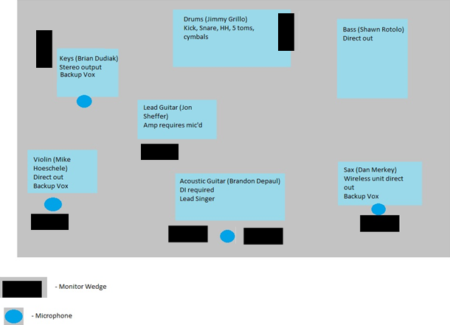
Audio Contact: Brian Dudiak (Keyboard player), bdudiak@juno.com, 585-802-9062.

Input List
Input | Channel | Connection Type |  | Monitor Mix
Kick | 1 | Mic/XLR needed |  | 1 – Wedge | Sax
Snare | 2 | Mic/XLR needed |  | 2 – Wedge | Lead Guitar
High Hat | 3 | Mic/XLR needed |  | 3 – Wedge | AcGuitar/Lead Singer
OH 1 | 4 | Mic/XLR needed |  | 4 – Wedge | Violin
OH 2 | 5 | Mic/XLR needed |  | 5 – Wedge | Keys
Bass | 6 | Mic/XLR needed |  | 6 – Wedge | Drums
Sax | 7 | Wireless
Fiddle | 8 | Mic/XLR needed
Electric Guitar | 9 | Mic/XLR needed
Acoustic Guitar | 10 | DI Required
Keys Left | 11 | DI Required
Keys Right | 12 | DI Required
Keys Vox | 13 | Mic/XLR needed
Violin Vox | 14 | Mic/XLR needed
Center/Main Vox | 15 | Mic/XLR needed
Sax Vox | 16 | Mic/XLR needed

