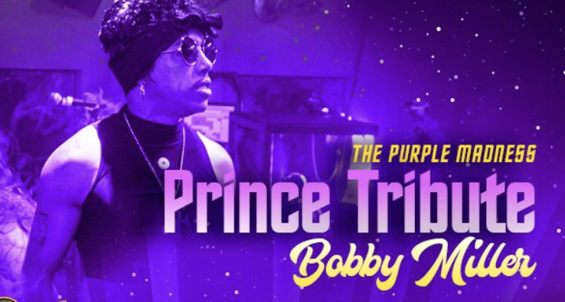

THE PURPLE MADNESS
TECHNICAL & HOSPITALITY RIDER

Advertising And Promotion
Billing on all advertising and publicity must appear as follows:
“The Purple Madness”

Purchaser agrees to use only artwork, photos and/or promotional material provided or approved by ARTIST/MGNT

Soundcheck/Miscellaneous
The sound, Stage and lightning systems must be fully operational prior to Band load-in time

Soundcheck shall be scheduled at least
2 to 3 hours prior to opening doors.
No changes to the stage will be allowed after sound Check

Artist requires a minimum one hour sound Check after completion of load-In and setup.
Unless otherwise agreed upon with artist representation

TECHNICAL RIDER

Note: If you have any problems, or if any of the items listed below will not be available, please contact us soon as possible at least one month prior to the event. If no contact is made, we’ll assume that this rider will be fulfilled to specifications.

Sound System Requirements:

- System shall have even coverage throughout the venue.

FOH SOUND CONSOLE:

- Console must have a minimum of 24 channels
- Console should be placed front center or beside the stage

FRONTLINE

- 220v (Clean Power Line)
- Monitors (7) Monitors will be mixed from FOH Console unless specified otherwise
- Side Fills – 2 (One for each side of the stage)
- Subs – 4 (Depending on Stage Size)
- (4) Shure sm58s Wired Microphones
- (1) Wireless Handheld (Beta 58) (For Prince)
- Microphone Stands (5)
- Drum Mics (Shure PG 6-Piece Drum Mic Kit)

Drums:

Standard 5 Piece professional grade/series drumkit – Pearl, Mapex, or Tama with Zildjian Cymbals
14inch hi hats, 18inch crash, 17inch crash, 20inch ride, 10 splash, 14 inch china
Drum Mics (Shure PG 6-piece Drum Mic Kit)
Drum Riser

Roland Spd-Sx (We will provide the Roland Drum Pad
The Hookup requires 2 (1/4 Inch Cables for Left & Right Stereo

Keyboard
Korg Triton, Yamaha Motif, Roland

Guitar Amps
Fender, Marshall or Behringer
Bass Amps
Fender Champion, Ampeg, or Marshall

(Note: We are open to other substitutes for Drums, Keyboard, Guitar & Bass Amps just let us no the brand you have)

Stage:

Stage Atleast 24’20’ or larger. Dance area must be clear of cables, stage boxes or other obstructions.

Lighting:

Purple Lighting (Movers, LED Pars, Wash Lighting)
Follow Me Spot

Effects:

1 or 2 Hazer or Fog Machine (Depending on Room Size)
Quick changing area off side of stage

Parking:

Parking should be provided at no cost to us close to the loading dock. (Please be aware that our travel arrangements if we do not fly in will usually be
One Conversion Van or A 34ft RV Motorhome)

Dressing Room:

In Addition to the Greenroom/Holding Room, Where food and drinks should be. At least 2 to 3 dressing rooms are required.

Security:

Please ensure at all times that the Stage, Back Stage, and Dressing Rooms are off limits and secure.

Merchandise:

An area of the lobby or other suitable place should be set aside for Meet & Greet & Merchandise. At least two tables will be needed for The Meet & Greet. If your able to rope it off will be great. Along with one security personnel

We would like to Thank You The Tech Crew Very Much In Advance For Everything!! We Really Appreciate Your Hard Work and Contributions To The Show!

